

NVMe-SM2260
User manual of Easy Analysis Tool

Updated date: 2015 / 12 / 22
Update History
Date | Description | Author
2015/09/09 | First version. | SMI
2015/12/22 | Update version for customer | SMI

Introduction
This document is for describing NVMe SM2260 easy analysis tool(EZTool). EZTool scans your system for SM2260 device and displays information. The tool can help you to update the firmware and get information from NVMe Device. All of copyrights are reserved for Silicon Motion Technology Corp.

- Scan device
Default page is used to provide Read Flash ID information. The information provided is retained CH/CE map info and running mode… etc.
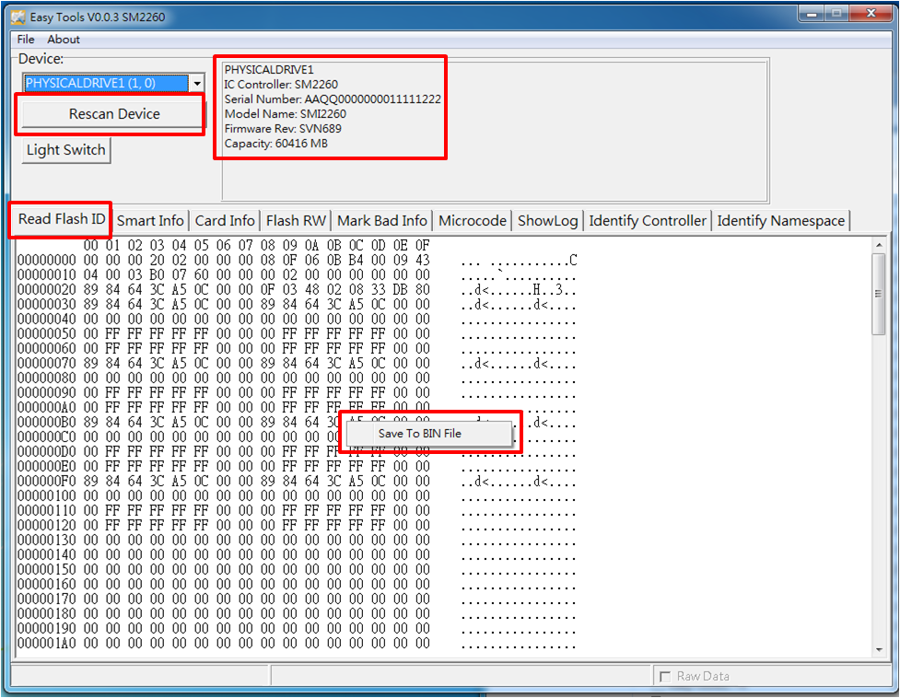
1-1: Auto scanning the device when executing the easy tool, If your system contains more than one SM2260 device, the tool displays each one it detects in a combo box list.
1-2: Click the “Rescan Device” if the device is not detected.
1-3: Display the basically information and flash vendor on the right side of window.
1-4: Click the right button of mouse can save the tag page information as BIN file format.
- Read Smart Info
This page is used to provide SMART and general health information. The information provided is over the life of the controller and is retained across power cycles.
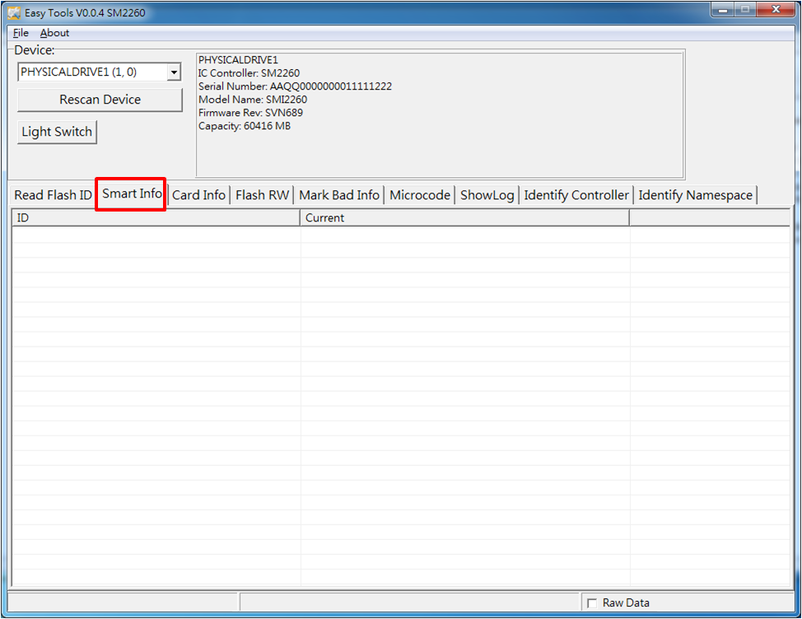
2-1: Right click the mouse button can save the tag page information as the TXT file format.
2-2: Select the “Raw Data” in the bottom right corner. and Click the right button of mouse can save the data as the BIN file format.
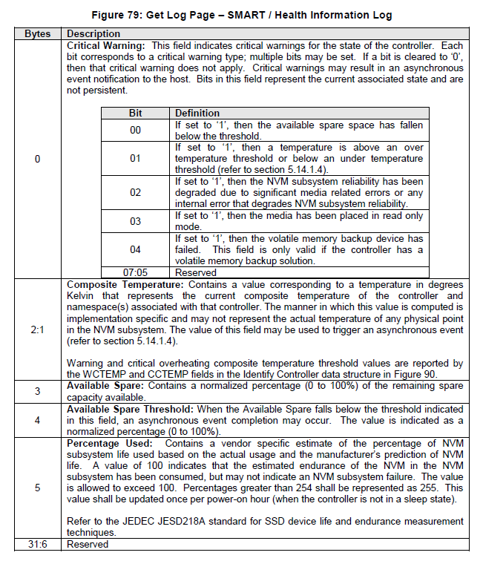
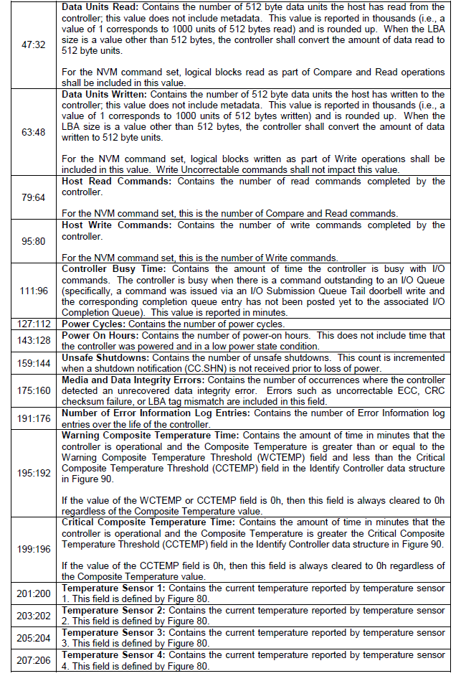
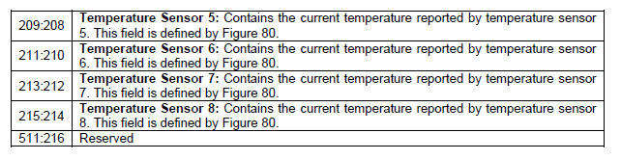

- Card Info
This page is used to provide <parameter> information. The information provided is card mode and flash option, etc information of the controller.
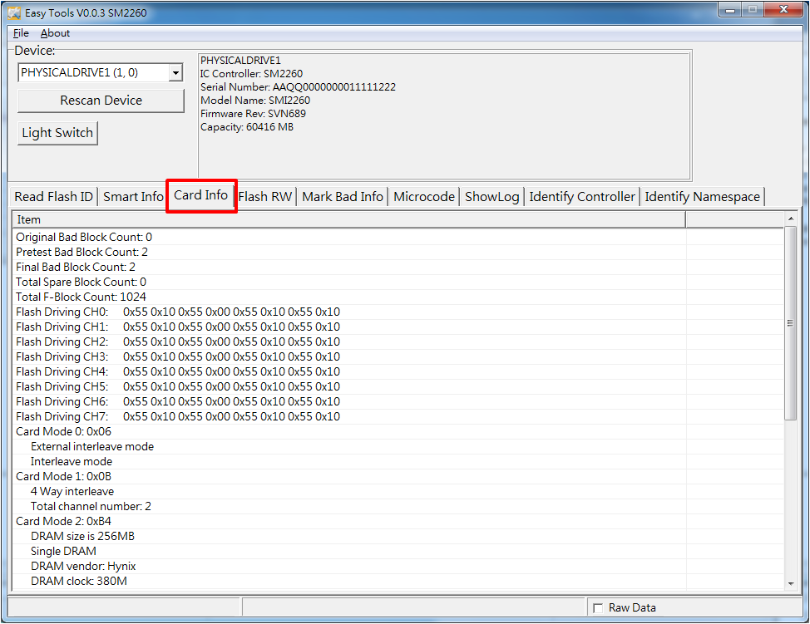
3-1: Right click the mouse button can save the tag page information as the TXT file format.
3-2: Select the “Raw Data” in the bottom right corner. and Click the right button of mouse can save the data as the BIN file format.
- Mark Bad Info
The page provided Mark Bad information(run time bad block).
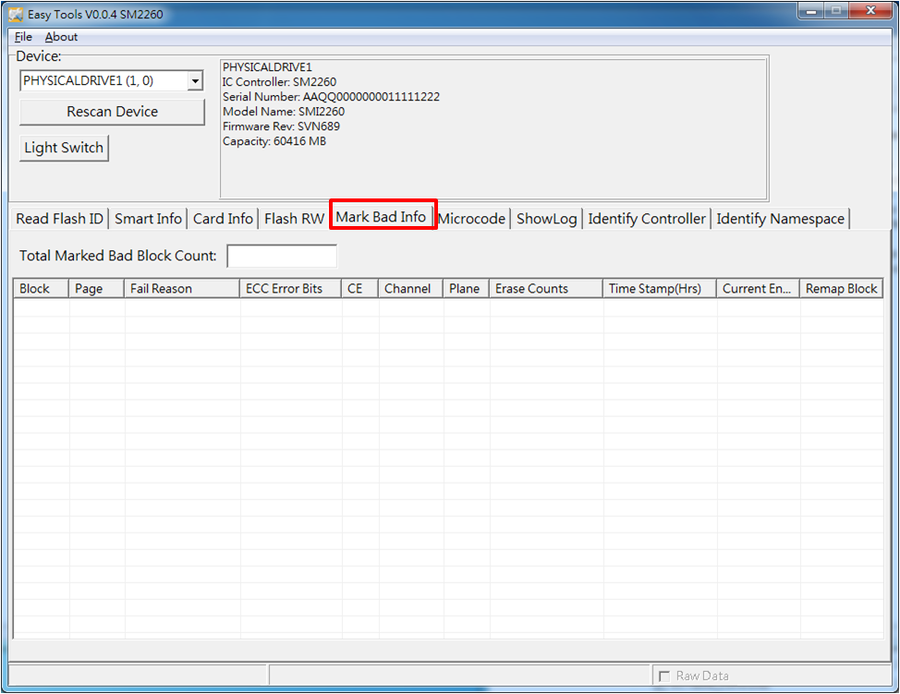
- Event Log
The page provided Event log information.
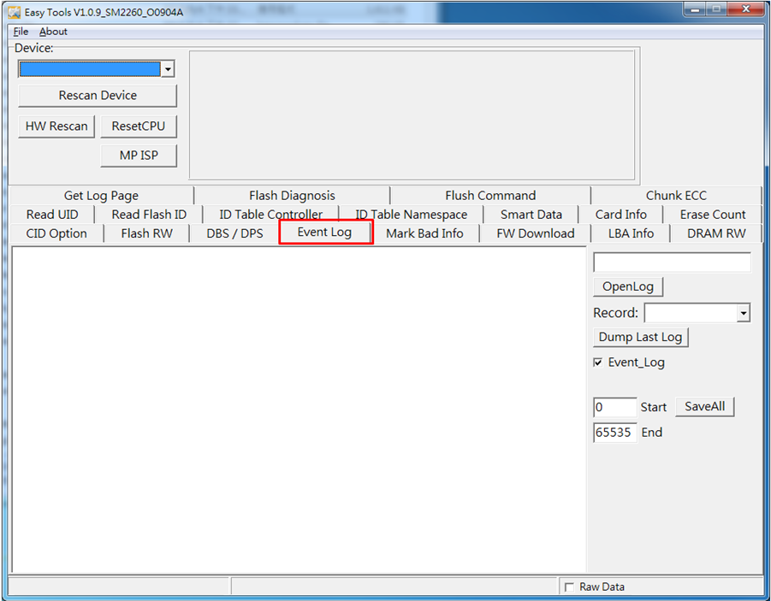

- Identify Controller
The page provided show Identify information. The Identify command returns a data buffer that describes information about the NVM subsystem, the controller or the namespace(s). The data structure is 4096 bytes in size. The data structure is based on the Controller or Namespace Structure (CNS) field.
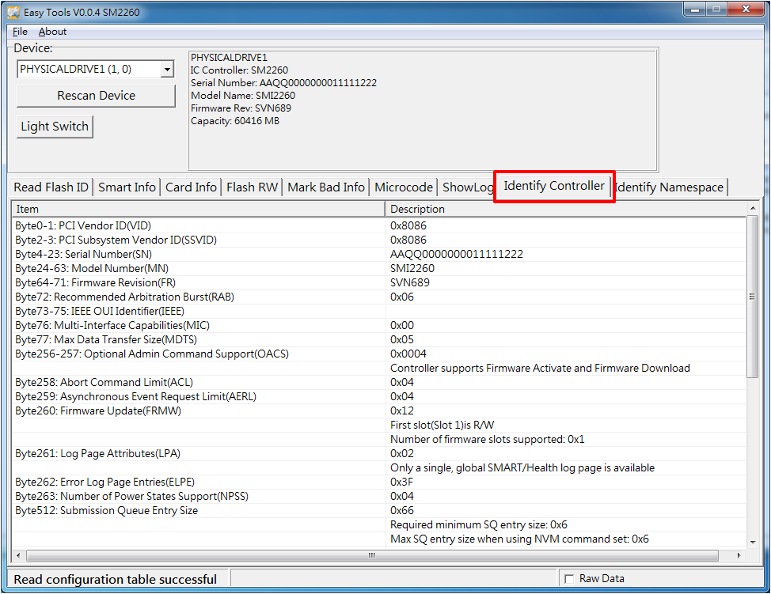
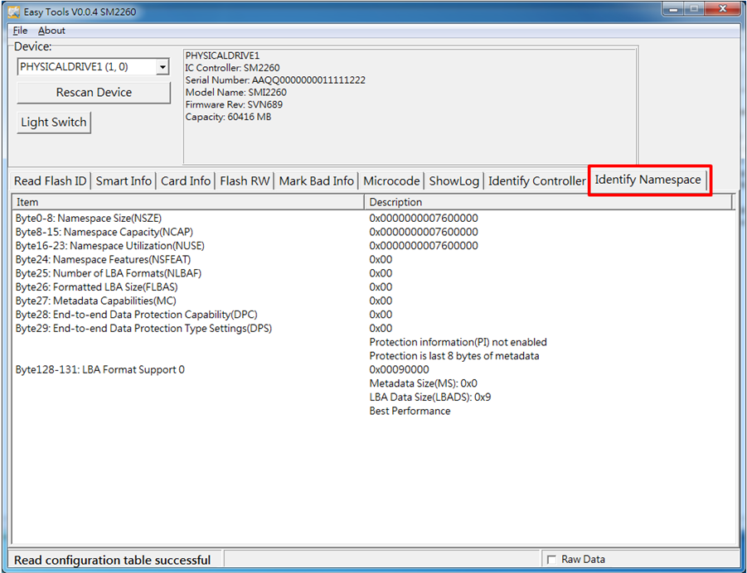
- CID Option
The page provided CID information. When start to read CID information, please select CSV file for parsing CID information.
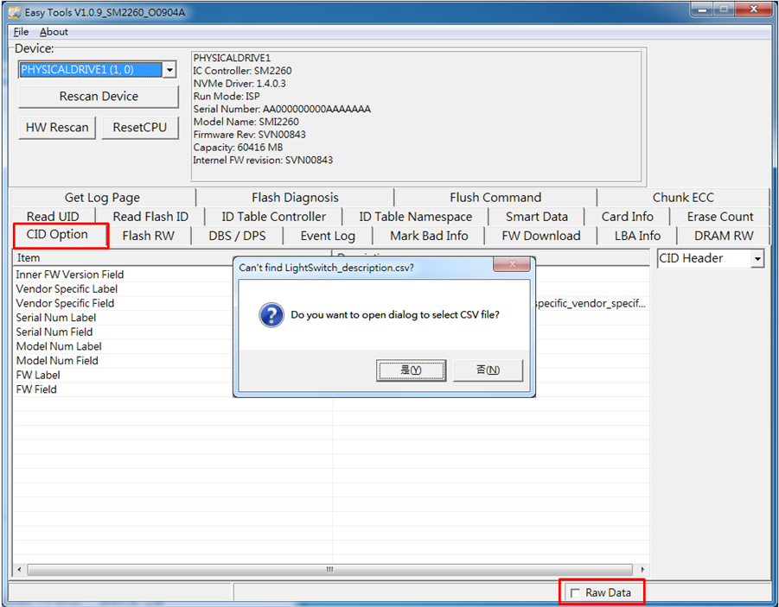
Click the right button of mouse on the raw data object can save the raw information as BIN file format.(Enable show Raw Data mode)
- Flash Diagnosis
The page provided show flash bad block information. The Flash diagnosis can quickly find out original/run time/pretest bad block information.
